|  |  |  |
| --- | --- | --- |
| Project Report | Medical clinic management | |
| **Name Navjot Singh** | |  |

Contents

Introduction 1

Objectives 1

Scope 2

Technology used: 2

Problem Statement 2

Methodology 3

Project schedule: 4

Functional Requirements 5

Register employee 6

Use case diagram : 7

7

Descriptive Use Cases 7

Login to the System 8

Pre-condition(s): 8

Main Flow: 8

Entity diagram 9

Testing 9

Unit Testing: 10

System Test: 10

User Acceptance Test: 10

Manual Testing VS Automation Testing 10

Conclusion 10

References: 11

Introduction   
  
The key function of a hospital is providing medical services and care to patients and facilitating

The doctors in patient management. The buildup of routine paper work including patient record

Management, scheduling and billing can hinder the efficient functioning of a hospital.

Effective hospital management requires keeping track of daily clinical activities and management

of patient records. However, keeping track of all of the activities include patient appointments,

visits, doctors and laboratory interactions, prescriptions and diagnoses through paper based records

is a very cumbersome and error-prone task. Electronic healthcare management systems

Supports automation of routing hospital management workflows including tracking of patient

Information, diagnoses, prescriptions, patient’s visit record keeping and laboratory test reporting.

To address these concerns, in this project we have developed an automated patient healthcare.

Objectives   
  
The objective of this project is to develop an electronic healthcare record management system for

Hospitals by automating the different workflows related to patient’s health record management.

Specifically, our focus is on automating patient health record management, appointment

Management, diagnosis, prescription and laboratory reports management workflows. The idea is

To provide a centralized interface to doctors for efficient access to patient records by integrating the different workflows in patient management.

# Scope

Our focus in this project is on automating the following workflows for hospital outpatient

Department:

1. Patient health record management
2. Appointment scheduling and tracking
3. Diagnosis management
4. Prescription management
5. Laboratory reports management

Technology used:   
  
visual studio   
MS SLQ server   
  
programming language   
  
MVC asp.net framework

# Problem Statement

We want to develop electronic patient health record management software that enables (i)

Patient record keeping including basic demographic, gender and age related details, family medical

History, and per hospital visit medical record; (ii) appointment scheduling with doctors; (iii) online

Diagnosis management by doctors; (iv) online laboratory test requests; and (v) efficient test

Reporting.  
  
Project activities Diagram

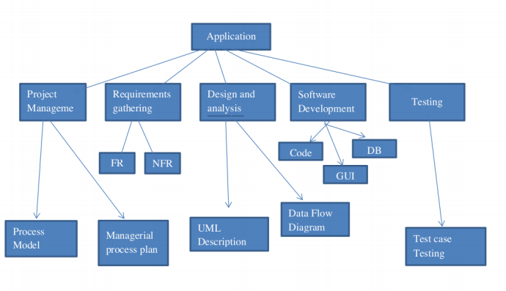

# Methodology

The process model that has been used for developing this project was iterative software

Development methodology. Iterative software development does not take complete requirements

Specification to begin with. Instead it works with partial specification and builds and delivers

Application module-by-module. Further requirements are clarified as a application version

Developed in an iteration is completed. So, for developing a website, I first planned and gathered

Requirements, then after | formulated a design and implemented it. After implementation, I did a

Verification process and from the results, I evaluated the performance. The loopholes and bugs

were identified by this process, so I planned to remove those bugs and errors. And the same process

is repeated until it becomes free of errors. So at last, deployed my project. Now, here is a full

Version of my project which will be under consideration for possible errors and omissions to be Occurred and the whole process to be repeated.

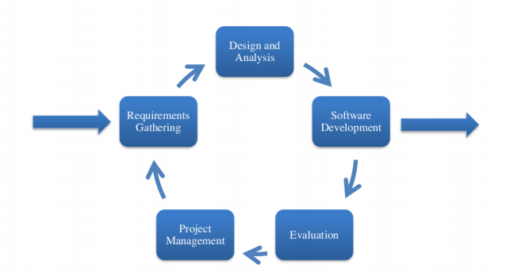

# Project schedule:

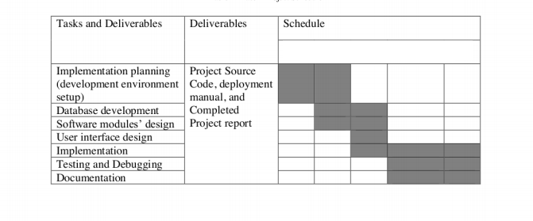

# Functional Requirements

Functional requirements are based upon the expected functioning of system you are creating. It shows the expected functionalities of how the interactions with the system should be which makes easy when we are coding or developing and designing the system. It helps the programmer to understand the flow of attraction between the user and the system. Functional

Requirements for my system are listed below:

* Registrar Adding Patients
* System should Book Appointment
* System should allow PA to book appointments
* System should allow PA to add vitals of patients
* System should allow PA to watch previous appointments history
* Admin Adding Employee
* System allows admin to add Doctor.
* System allows admin to add PA
* System allows admin to add Registrar
* System allows admin to add Lab attendant
* Admin Adding Employee
* Lab Attendant Creating Reports
* System should allow user to add New Test
* System should allow user to create lab reports
* System should allow user to create patient’s report

# Register employee

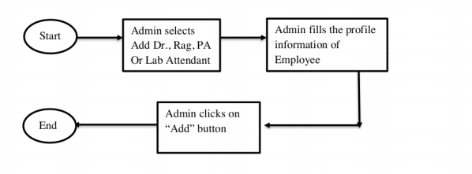

# Use case diagram :

# 

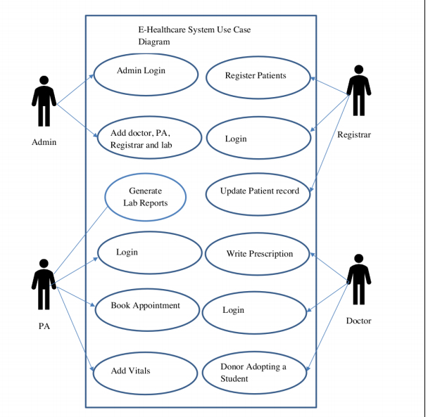

# Descriptive Use Cases

## Login to the System

Description:

This use case describes the user login process which enables the user to access the system as per

The assigned privileges.

Actors: Admin, Doctor, PA, Registrar and Lab

## Pre-condition(s):

User must possess an account to login to the system.

## Main Flow:

* Use case starts when user opens the application.
* System displays the login screen.
* Users shall provide his/her username and password on login entry screen
* User shall click on submit button
* System shall authenticate the user and give privileges according to user type
* System takes the user to the home page  
    
  Database architecture diagram

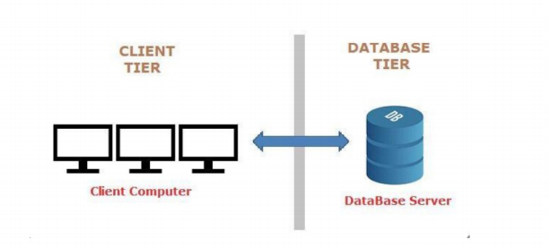

# Entity diagram

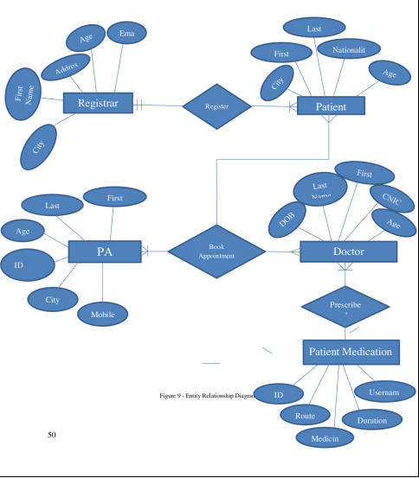

# Testing

Testing

Testing is critical for a newly developed system as a prerequisite for it being put into an environment where the end users can use it. Exhaustive testing is conducted to ensure accuracy and reliability and to ensure that bugs are detected as early as possible. In the process of designing the system, three levels of testing will be conducted, namely, unit testing, user acceptance and system test.

## Unit Testing:

Unit test is where the system is tested partially and independently, component by component, to

ensure that particular portion or module is workable within it. In the development of the of E-

healthcare system, each component will be tested independently before finally integrating each

of them into one system.

## System Test:

A system normally consists of all components that makeup the total system to function. It will be

required to ensure the smooth running of the system as a whole, and it should perform as

expected and as required. Here, technical and functional testing will be performed. The technical

testing will involve the process of testing the systems compatibility with the hardware, operating

system, data integrity in the database and user authorization access rights.

## User Acceptance Test:

Users will be involved so as to analyses acceptability and usability and also to identify areas that may require modification before the system can fully be commissioned for use.

# Manual Testing VS Automation Testing

I chose to use manual testing for this application because of following reasons:

* Short-Term Cost Is Lower
* Buying a tool for testing is expensive.
* Automatic testing is not done in a way as a real Actor does.
* Automatic testing is robotic and not prepared to handle some extra real

# Conclusion

In this project, we have developed an E-Healthcare system to computerize patient management workflows in a hospital. The software takes care of all the normal hospital specifications and is capable of providing easy and effective storage of patient-related information that comes up to the hospital. It generates test reports; provides details of the prescription including various tests and prescribed medicines. In future, we plan to enhance the capabilities of this software by adding more modules related to in-patient management and billing.

# References:

1. Moore, (2015, June 30), "5 Reasons Why Autonomous Cars Will Revolutionize Ecommerce", Blue Moon/Digital. Recovered from http://bluemoondigital.co/our-blog/creator/jared-m/Mitra, Abhijit (2013),
2. "web based business in India-an audit", International diary of promoting, budgetary administrations and the board look into, vol.2, no. 2, pp. 126-132 Ozok, A.A., Oldenburger, K., and Salvendy, G. (2007),
3. "Effect of Consistency in Customer Relationship Management on E Commerce Shopper Preferences" Journal of hierarchical registering and electronic business" 17.4, pp.283–309
4. Patrick Nelson, (2013, June 21), How 3D Printing Will Revolutionize E-Commerce, E-trade times. Recovered from http://www.ecommercetimes.com/story/78298.html Pyun,C.,S.,
5. Scruggs,L.,and Nam,K. (2002), "Web banking in the U.S., Japan and Europe", worldwide business review,pp.73-81 Rust,R.,T., and Chung,T.,S. (2006) "Advertising Models of Service and Relationships" Marketing science,25.6, pp. 560-580